**LEBANESE AMERICAN UNIVERSITY**

**USAID – HIGHER EDUCATION SCHOLARSHIP PROGRAM**

**HES - Volunteering Program Verification Form**

This form is to be used to document volunteering hours. If a student volunteers for multiple organizations, a separate form must be used for each organization. **This form must be turned in by the 28th of each month, the latest.**

I certify that the scholar Sara al jaafil completed a total of 5 hours of service at InnovaThrive.

The hours were completed hours as per the below:

Hours # 0 (date) _2/12 – 6/12_ (initials of supervisor) __A.K.___

Hours # 0 (date) _9/12 – 13/12_ (initials of supervisor) __A.K.___

Hours # 0 date) _16/12 – 20/12 (initials of supervisor) __A.K.___

Hours # 5 date) _23/12 - 27/12 (initials of supervisor) __A.K.___

Brief description of the activities the scholar performed or participated in:

I had a research about AI in automated health diagnostics in remote areas where I stated its definition, technologies included, the applications, statistics, the advantages and disadvantages, some challenges, future research and lastly the references that I got the information from.

Written feedback about the scholar’s performance:

Sara demonstrates comprehensive research and analytical skills in the area of AI-driven health diagnostics. Her ability to present a well-rounded view of the topic, including future possibilities, showcases strong problem-solving abilities.

Please rate the overall performance of the scholar at your organization:

|  |  |  |  |
| --- | --- | --- | --- |
|  | Mastery (5) | Proficient (3) | Emerging (1) |
| **Problem solver** | X |  |  |
| **Engaged & Committed** | X |  |  |
| **Open-minded & multicultural** | X |  |  |

Signature

& stamp

__________________________

_

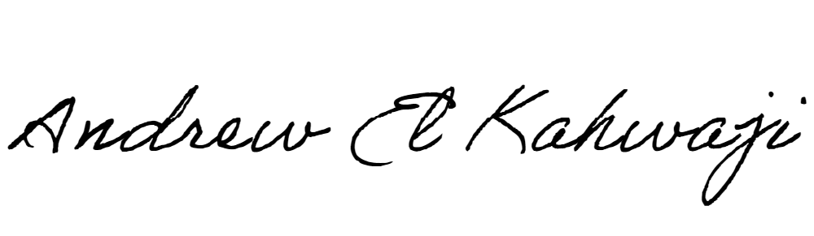

Printed Name _Andrew El Kahwaji_

Date __26/12/2024___

Email __andrew.lifesculptor.coo@gmail.com __

Phone __+961 71 914 378__